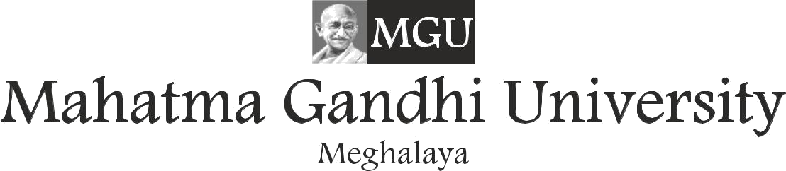

**Recog. by University Grants Commission & Bar Council of India, Member of AIU.**

EXAMINATION FORM

DEC - 2022 SESSION REGULAR STUDENTS

PLEASE FILL IN THE FORM IN ENGLISH CAPITAL LETTERS ONLY.

STUDENT NAME (Mr./Ms.).............................................................................................

FATHER NAME (Mr.)............................................................................................................

ENROLLMENT NO.: .......................................................................................................

PROGRAM: ....................................................................................................................

SEMESTER/YEAR: ........................................................................................................

PHONE NO.: ...................................................................................................................

E-MAIL: ..........................................................................................................................

ADDRESS: ......................................................................................................................

|  |  |  |  |
| --- | --- | --- | --- |
| S.No. | SUBJECT CODE | SUBJECT NAME |  |
| 1 |  |  |
| 2 |  |  |
| 3 |  |  |
| 4 |  |  |
| 5 |  |  |
| 6 |  |  |
| 7 |  |  |
| 8 |  |  |
| 9 |  |  |
| 10 |  |  |

Bank Draft/University Receipt No. Date: Amount

(Bank Draft should be drawn in favour of MAHATMA GANDHI UNIVERSITY, payable at Shillong)

I hereby declare that all the information given above are true to the best of my knowledge.



Signature of the Candidate

Date

Of ce Signature & Seal

It is to certify that the student has submitted all the assignment(s)/ projects (if any)For the subject (s) lled in the examination form and cleared minimum attendance criteria for the Current semester.

It is to certify that the student has cleared all his nancial dues for the current semester/year.

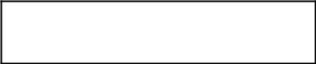

Signature (HOD)

Signature (Accounts & Finance)